Section 1: Case Summary

Scenario Title: | Hypertensive Encephalopathy
Keywords: | Delirium, hypertensive emergency
Brief Description of Case: | This case involves the assessment and management of an acutely confused patient with hypertensive encephalopathy. The resident is expected to initiate appropriate supportive measures (ensure working IV, oxygen, monitors) while obtaining a focused history and performing a focused physical exam, including a detailed neurologic assessment. They should recognize the elevated BP and order a work-up for end-organ damage. The patient will require transfer to a critical care setting for administration of acute BP lowering agents including involvement or RACE or a similar high acuity response team.

Goals and Objectives
Educational Goal: | To practice the initial assessment and management of a hypertensive emergency
Objectives:  (Medical and CRM) | - Review the initial approach to the unstable floor patient  - Work through the differential for acute confusion  - Recognize and initiate initial management of hypertensive emergency  - Demonstrate an organized management plan (IV, O2, monitors, call for help, consider BP lowering therapies)  - Initiate work-up for the underlying etiology of the hypertensive emergency
EPAs Assessed:

Learners, Setting and Personnel
Target Learners: | ☒ Junior Learners |  | ☐ Senior Learners |  |  | ☐ Staff
 | ☒ Physicians | ☐ Nurses |  | ☐ RTs | ☐ Inter-professional
 | ☐ Other Learners:
Location: | ☒ Sim Lab |  | ☐ In Situ |  |  | ☐ Other:
Recommended Number of Facilitators: | Instructors: 1
 | Sim Actors: 1
 | Sim Techs: 1

Scenario Development
Date of Development: | 2015
Scenario Developer(s): | Dr. Tim Chaplin
Affiliations/Institutions(s): | Queen’s University
Contact E-mail: | chaplintim2@gmail.com
Last Revision Date: | Jan 2020
Revised By: | Dr. Chris Heyd
Version Number: | 1

Section 2A: Initial Patient Information

- Patient Chart
Patient Name: Micah Brown |  |  |  | Age: 73 | Gender: M | Weight: 90kg
Presenting complaint: Confusion
Temp: 37.2 ºC | HR: 88 | BP: 227/134 |  | RR:22 | O₂Sat: 94% | FiO₂: Room air
Cap glucose: 6.6 |  |  |  | GCS: 14 (E4 V4 M6)
Triage note:
It is 3:00 am, you are called to the floor to assess a 73M, Mr. Brown, who was admitted to general surgery 2 days ago, and has a scheduled large bowel resection for diverticulitis tomorrow. He has been undergoing bowel prep.
You are called because he is experiencing confusion, shortness of breath, and chest heaviness.

Allergies: None
Past Medical History:  Prostatectomy 5 years ago for prostate cancer  Frequent diverticulitis flares requiring antibiotics |  |  | Current Medications:  coversyl 4mg BID  metoprolol 50mg BID  hydrochlorothiazide 25mg daily  multivitamin

Section 2B: Extra Patient Information

A. Further History
Include any relevant history not included in triage note above. What information will only be given to learners if they ask? Who will provide this information (mannequin’s voice, sim actors, SP, etc.)?

RN to provide when asked: This is your third shift with MR. Brown. His baseline is very pleasant, alert and oriented. You found him this morning confused, appearing unwell (flushed, diaphoretic) and you have called the resident to assess Mr. Brown.

At 2-3 minutes, nurse will report that regular anti-hypertensives have been held as a pre-op strategy.

B. Physical Exam
List any pertinent positive and negative findings
Cardio: Normal | Neuro: Confused, slow to answer, rotary nystagmus
Resp: Normal | Head & Neck: Normal
Abdo: Diffuse tenderness | MSK/skin: Diaphoretic
Other: Appears unwell

Section 3: Technical Requirements/Room Vision

A. Patient
☒ Mannequin Adult
☒ Standardized Patient (If possible, will add to the realism)
☐ Task Trainer
☐ Hybrid
B. Special Equipment Required
Vitals machine
Manual BP cuff

C. Required Medications
None

D. Moulage
Diaphoresis
Hospital Gown
IV in situ

E. Monitors at Case Onset
☐ Patient on monitor with vitals displayed
☒ Patient not yet on monitor
F. Patient Reactions and Exam
Include any relevant physical exam findings that require mannequin programming or cues from patient
(e.g. – abnormal breath sounds, moaning when RUQ palpated, etc.) May be helpful to frame in ABCDE format.

Pale, diaphoretic, unwell
Disoriented, slow to answer
Rotary nystagmus
Moans to palpation of the abdomen

Section 4: Sim Actor and Standardized Patients

Sim Actor and Standardized Patient Roles and Scripts
Role | Description of role, expected behavior, and key moments to intervene/prompt learners. Include any script required (including conveying patient information if patient is unable)
RN NOTES
- This is your third shift with MR. Brown. His baseline is very pleasant, alert and oriented. You found him this morning confused, appearing unwell (flushed, diaphoretic) and you have called the resident to assess Mr. Brown.
- If asked, you are not able to give IV BP meds on the floor (RACE may do this for a brief time).
- At 2-3 minutes nurse will report that regular anti-hypertensives have been held as a pre-op strategy.

Section 5: Scenario Progression

Scenario States, Modifiers and Triggers
Patient State/Vitals | Patient Status | Learner Actions, Modifiers & Triggers to Move to Next State |  | Facilitator Notes
1. Baseline State  Rhythm: Sinus  HR: 88  BP: 227/134  RR: 22  O₂SAT: 94%  T: 37.2ºC  GCS: 14 (E4 V4 M6) | Disoriented, slow to answer | Expected Learner Actions  History and Physical  Neuro exam  Full set of vital signs  Cap sugar  EKG  Review medications  Send bloodwork  Supplemental O₂  Call for senior surg resident | Modifiers  Changes to patient condition based on learner action  -  -  Triggers  For progression to next state  All actions complete or 3-5 mins elapsed → 2. Unchanged
2. Unchanged  Rhythm: Sinus  HR: 88  BP: 234/138  RR: 20  O₂SAT: 99% (2L NP)  GCS: 14 (E4 V4 M6) | Same | Expected Learner Actions  Arrange CT head  Consider anti-HTN agent  Serial BP checks  Call RACE/medicine | Modifiers  Give oral anti-HTN → no change  If requests IV antihypertensives RN to prompt “we cannot give IV without high acuity team (RACE)”  Triggers  All actions complete → 3. Results Back
3. Results Back  HR: 88  BP: 234/138  RR: 20  O₂SAT: 99% (2L NP)  GCS: 14 (E4 V4 M6) | Same | Expected Learner Actions  Review bloodwork  Review CT scan  Arrange higher level of care | Modifiers  Triggers  Discuss transfer with RACE → End Case | Give Bloodwork and CT Results at beginning of state

Appendix A: Laboratory Results

CBC  WBC 12.5  Hgb 133  Plt 270  Lytes  Na 136  K 3.6  Cl 97  HCO₃ 24  Urea 8.1  Cr 143  Glucose 6.9  Extended Lytes  Ca 1.33  Mg 0.70  PO₄ 0.78  Albumin 38  VBG  pH 7.38  pCO₂ 36  HCO₃ 25  Lactate 1.2 | Cardiac/Coags  Trop 4  INR 1.0  aPTT 30  Biliary  AST 44  ALT 38  GGT 40  ALP 97  Bili 7  Lipase 24  Tox  EtOH neg  ASA neg  Tylenol neg  Osmols 304

Appendix B: ECGs, X-rays, Ultrasounds and Pictures

Paste in any auxiliary files required for running the session. Don’t forget to include their source so you can find them later!
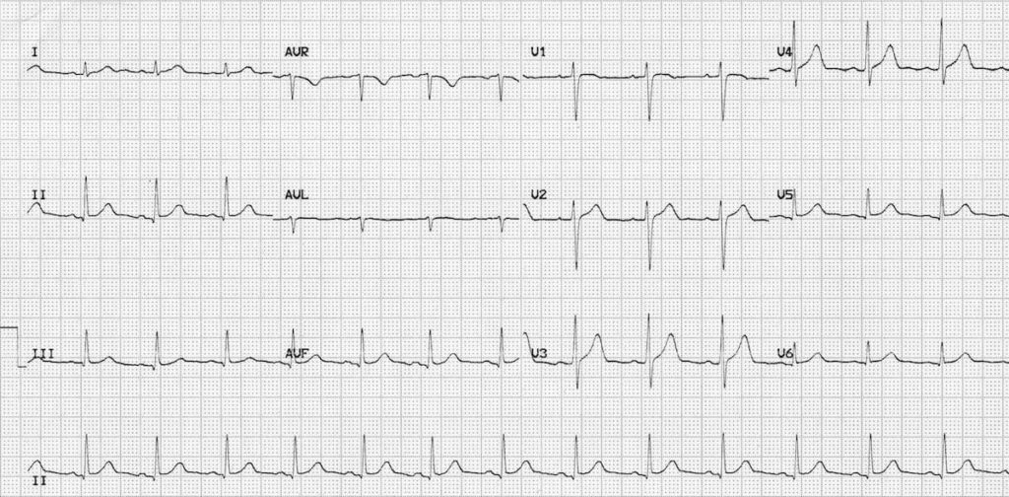
Normal Sinus Rhythm (From Life in the Fast Lane Blog)
https://litfl.com/normal-sinus-rhythm-ecg-library/

CT Head Report

Clinical details
Acute confusion

Technique
CT head without contrast

Findings
No mass, hemorrhage or hydrocephalus. Basal ganglia and posterior fossa structures are normal. No established major vessel vascular territory infarct. No intra or extra axial collection. The basal cisterns and foramen magnum are patent. The air cells of the petrous temporal bone are non-opacified. No fracture demonstrated.

Conclusion
Normal study

Appendix C: Facilitator Cheat Sheet & Debriefing Tips

Include key errors to watch for and common challenges with the case. List issues expected to be part of the debriefing discussion. Supplemental information regarding any relevant pathophysiology, guidelines, or management information that may be reviewed during debriefing should be provided for facilitators to have as a reference.

- Recognize the unstable floor patient and call for help
- Review differential diagnosis and work-up of confusion
- Clear communication with team/maintain situational awareness as the leader
- Discuss logistics of transferring to a critical care bed (ie RACE nurse is key)
- Define hypertensive emergency: “a high blood pressure AND signs of end-organ dysfunction”
  - No formal numbers… but generally >180/110
- Describe an approach to treating HTN emergencies
  - Many agents available… use what you are comfortable with, target a reduction in SBP of roughly 25% in first 1-2hours.
  - Arterial line and monitored setting

References

1. https://emcrit.org/ibcc/hypertensive-emergency/
2.
3.

